Suzanne Petersen - Award Winning Songwriter Australian Blues and Roots Charts

Engaging vocal style wins audiences wherever she goes with her eclectic tastes spanning blues roots and ballads.

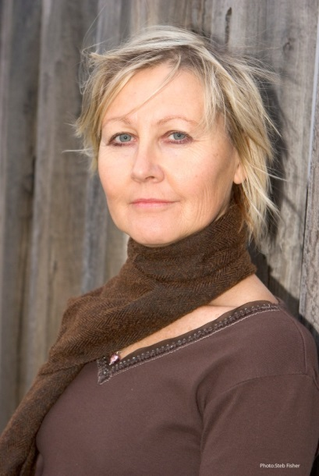
Suzanne studied classical piano at boarding school in Brisbane but commenced a professional career playing guitar at Hooters Mexican Restaurant in the evening hours while surfing in the daylight hours making it to the Australian Titles. She went to Cairns with the Tim Gaze band doing songwriter solo gigs sharing the stage and honing the craft of singing by watching Judy and Bruce Parkinson on vocals. Tim was commissioned to Sydney to record songs for surf movie Band on the Run. Suzanne wrote, sang and improvised flute for the movie landing a publishing contract with Leeds. After the movie she got a barmaid job at the Kirribilli Hotel and played guitar and sang there on the weekend nights. She also played Sydney pubs and bars playing solo Guitar/vocals to punters.

Destination Melbourne circa 1980 on meeting Dutch Tilders a long partnership developed and she was flautist in his band touring with the RnB 6 supporting acts like George Thorogood. For a brief stint Suzanne formed her own band then got a lot of work doing guitar/vocals with John Cameron on Bass working all around Victoria and Melbourne, more recently singing with his big band “Out For The Count” at Inverloch Jazz Festival. Piano bars were profitable in the 80’s and 90’s and while attaining a B.ED in Music at Melbourne University and jazz piano tuition with Helen Jowsey Suzanne got back to her first instrument the piano, and rediscovered Billy Holiday and Bessie Smith and a wealth of other early artists. She played piano residencies at 5 Star hotels such as the Windsor, Sofitel and Eden on the park and local live venues such as the Town Hall Hotel, South Melbourne.

In 2007 she collaborated with an old friend Mal Clarke of the Bullamakanka band and released her first album of original material Here Is My Song. The songs catch some of the spirit of Australia. She played with Mal at the Outback Pioneer at Ayers Rock resort and after that a piano residency at Mantra Tree Tops Port Douglas.

In Melbourne Suzanne had friends like the late great Gil Askey who played with her on occasional sold out gigs at the Market Street Tavern, Nunawading, contributing to a deeper knowledge and understanding of American blues and jazz. Suzanne’s second album I Foresaw This Trouble had14 original tracks including 8 swinging blues tracks influenced by her entrenchment in the Melbourne blues scene. Suzanne got better than good recognition with this album making no. 5 in the Australian Blues and Roots Radio Charts in December 2014 and remaining in the charts for at 8 months in 2015. All the tracks have a good groove and are appealing to a wide audience as it encompasses some roots, folk, gospel and ballads. Gary Norman Guitar, Mike Mathews Bass, Justin Humphries drums, guest harmonica Ian Collard, guitar Geoff Achison, drums Gideon Marcus.

Suzanne & the Top Shelf played local venues such as the Lomond Hotel and regular gigs at Prahran Market. The Reunion Café at Surrey Hills Music Festival dinner and show sold out and was also featured artist at Eltham Jazz Food & Wine Festival and Moomba Festival.

Suzanne recorded So Many Nights consisting of 13 original tracks also making the top 25 Australian Blues & Roots radio Charts 2017 2018. The roller coaster of life then spiralled her into writing ten more quality original tracks which she titled Our Street soon to be released.

Contact Suzanne
Mobil: 0459033324
Email: petersensuzanne9@gmail.com
Website: http://suzannepetersen.com 5.5.2020

