Suzanne Petersen is an accomplished pianist and flautist, a lyrical poet and vocalist.
Suzanne writes about life experiences. Folk, pop, blues and roots, with a bit of the Jazz Chanteuse thrown in. Suzanne’s sublime singing and poignant lyrics tell of a life well-lived.

Suzanne got her start in the 70’s playing Carol King and Neil Young tunes on guitar at Hooters Mexican restaurant in her home town of Coolangatta. She was one of the few girls to surf in the Australian titles in the 70’s. Her love of the surf and sea led to a collaboration with guitarist/songwriter Tim Gaze, writing the score for the Australian surf movie “Band on The Run”. Suzanne wrote and performed two of the songs on the soundtrack.

In the 80’s, a chance meeting in Sydney with blues legend Dutch Tilders was Suzanne’s introduction to the blues. She went on to tour extensively around Australia with Dutch’s band as flautist and backing vocalist. Suzanne was with Dutch’s band when they supported George Thorogood at the Palais.

During the late 80’s, Suzanne went to Box Hill College of Music, then Melbourne University, where she attained her Bachelor of Education in music while studying jazz piano with Helen Jowsey. She paid her way by playing in piano bars and at 5-star hotels in Melbourne. In 1998 and 2001, Suzanne received awards from Unisong for her original compositions.

2007 saw a collaboration with old friend Mal Clarke of the Bullamakanka Band and the release of her first album of original material, “Here Is My Song”. The songs speak of life on the land in country Australia.

For a change of gear in 2014, Suzanne released her second album “I Foresaw This Trouble”, a swinging roots, blues and ballads album of 14 original songs. The album features performances by virtuoso harmonica player Ian Collard and guitarist extraordinaire Geoff Achison. The album went to number 5 in the Australian Radio Blues and Roots Charts and remained there in 2015.

“Our Street”, released in 2020, is a poignant and moving tribute to Suzanne’s late and much-loved husband, Patrick.

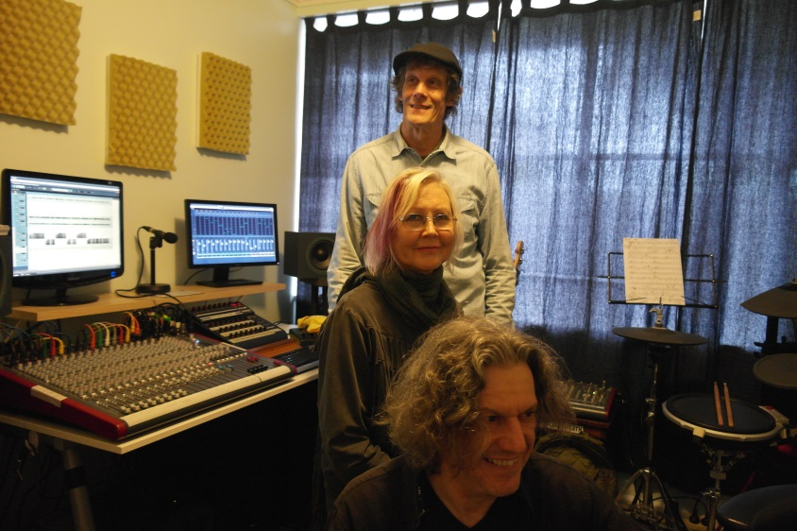

Music and Web Links:
http://www.suzannepetersen.com
https://www.youtube.com/watch?v=EtFCukVSWaw

Suzanne Petersen Contact - Phone: 0459033324
Email - petersensuzanne9@gmail.com

